Open Browers and type into address bar

install influxdb 2.6

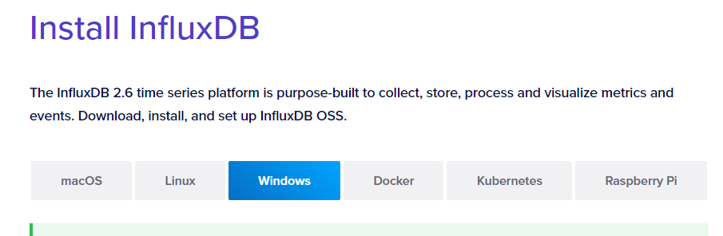

Take note that unlike v1.8. The InfluxDB server and Client requires two seperate downloads.

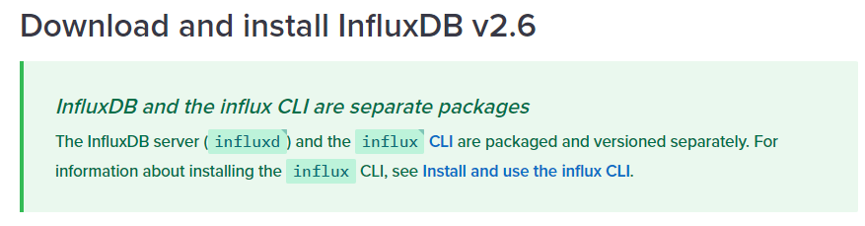

Select Windows, then scroll down to

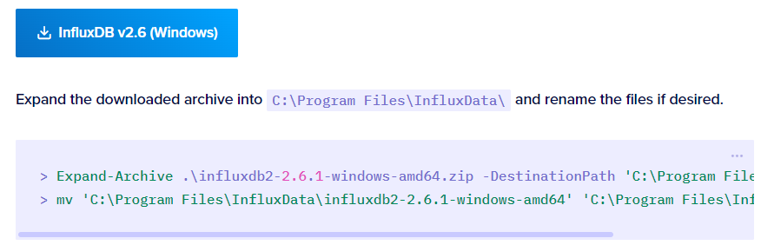

You can ignore this

Click the InfluxDB v2.6 (Windows) download icon.

influxdb2-2.61-windows-amd64.zip will be downloaded to your Downloads Folder

Next, go to the downloads folder to extract the zip file

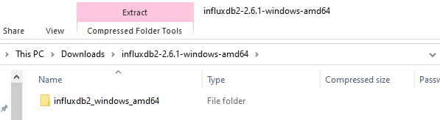

Copy influxdb_windows_amd64 folder to your C Drive Root Directory

c:\influxdb2_windows_amd64

you can rename this folder name to something simpler like c:\influxdb2

Next scroll down to

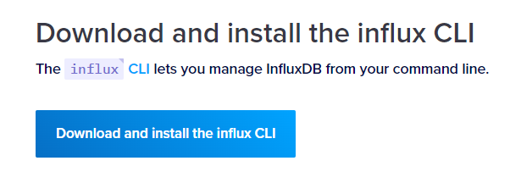

Click on the Download and Install the influx CLI icon to download the client

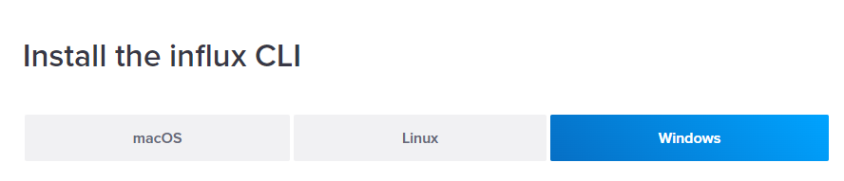

Select Windows

When you see this

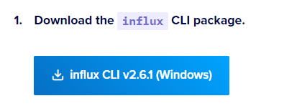

Click the download link to download the client

You will see this in your Downloads folder

influxdb2-client-2.6.1-windows-amd64.zip

Extract this zip file

copy this folder **influxdb2-client-2.6.1-windows-amd64**

to c drive root directory

Open the directory and you will see these files

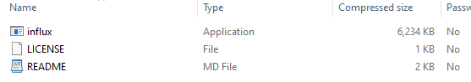

influx.exe is the client for InfluxDB CLI (command line interface)

copy influx.exe to the same folder as the influxdb server where influxd.exe is.

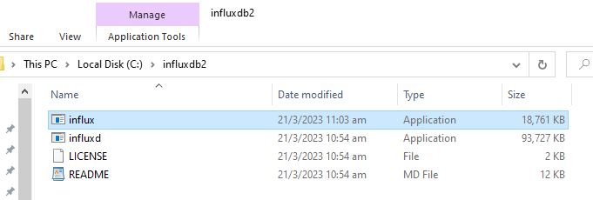

In C: influxdb2 folder you now have the influx server (influxd.exe)

and the client program (influx.exe)

To Start the influx server.

Start a terminal session

cd to the folder where influxd.exe is

**Type influxd to launch the server**

To start the client CLI

**Type influx v1 shell**